Digital Forensics Investigation Report: Wes Mantooth Case

Investigator: Ethan Spade

Case File: Mantooth.E01 Analysis

Date: 10/26/25

Tools Used: Autopsy, Registry Explorer, Hex Workshop, Snip Tool

**1. Executive Summary**

This report details the forensic examination of a disk image labeled Mantooth.E01, associated with the primary Windows user Wes Mantooth. The investigation aimed to reconstruct user behavior, identify potential criminal activity, and verify the integrity of digital evidence.

The analysis revealed a pattern of suspicious and potentially illegal digital behavior, including web searches related to drug manufacturing and credit card theft, email correspondence suggesting illicit collaboration, and the installation of potentially malicious software.

**2. Scope of Investigation**

The primary objectives of this analysis were to:

* Identify the main user and their account activity.
* Examine system information and verify configuration details.
* Reconstruct internet browsing history and email correspondence.
* Identify and correlate artifacts suggesting illicit or suspicious behavior.
* Document all significant findings supported by verifiable evidence.
* All evidence was examined using industry-standard forensic tools, ensuring data integrity and traceability throughout the process.

**3. Hash Verification**

The MD5 hash of the acquired disk image (Mantooth.E01) was verified against the corresponding Mantooth.E01.txt file. The values matched, confirming the image’s integrity and authenticity prior to analysis.

**Essential Flags:**

**1. Verify the MD5 hash of the image with the related Mantooth.E01.txt file.**

FTK imager shows the MD5 hash found on the eo1 file matches that listed in the provided hash.

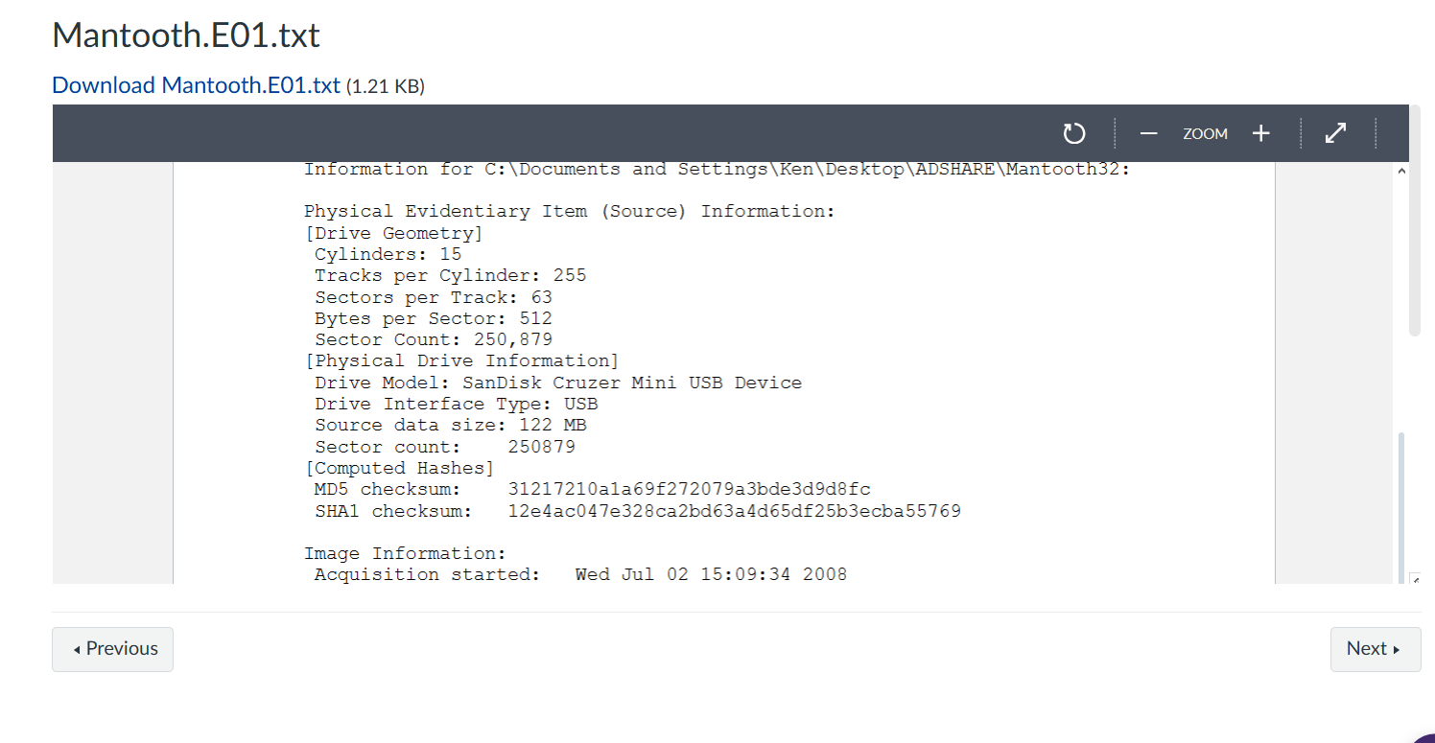

Figure Shows the provided hash

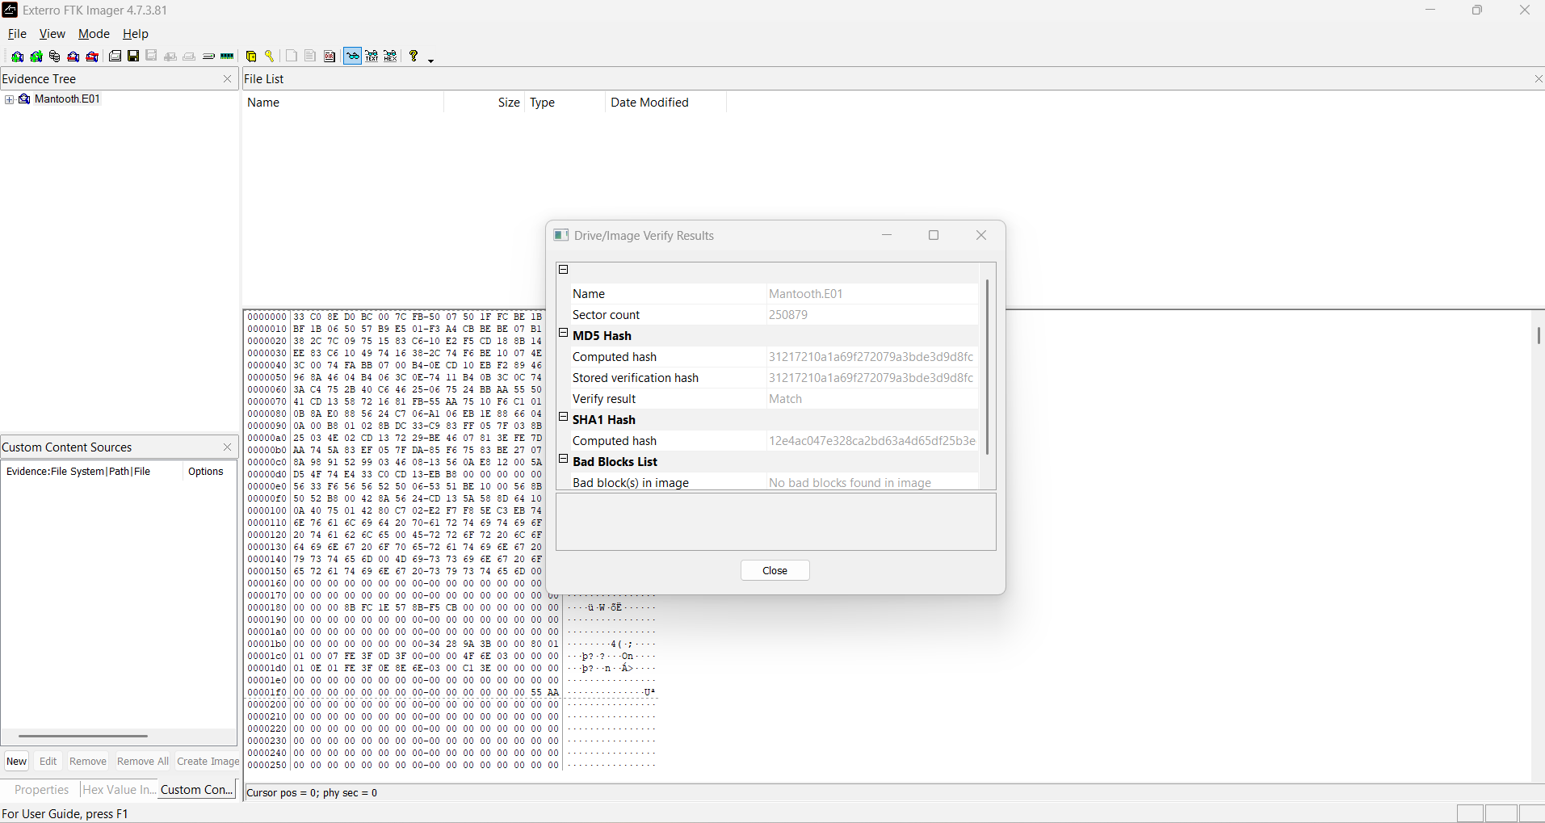

Figure Shows the MD5 obtained from FTK Imager

**2. User Account Discovery: What is the name of the main Windows user account?**

The primary user account belongs to Wes Mantooth, who has logged in 96 times. The account currently uses a non-expiring password, which is not configured as a required credential update.

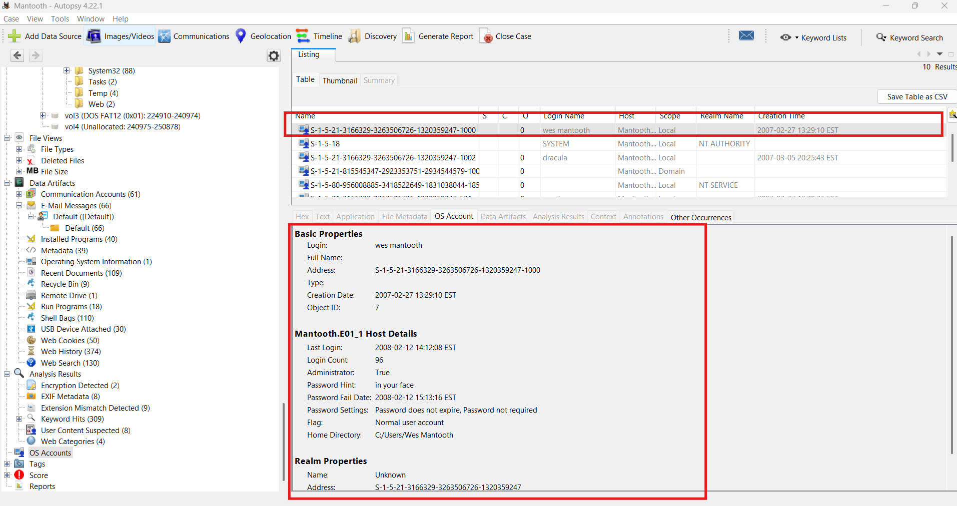

Figure shows the main user account

**3. User Account Discovery: What is the last login time of the main user?**

The most recent login for Wes Mantooth occurred on February 12, 2008, at 14:12:08 EST.



Figure Shows last login of the main user

**4. Operating System Version: What operating system is installed?**

The operating system is Windows Vista (™) Ultimate.

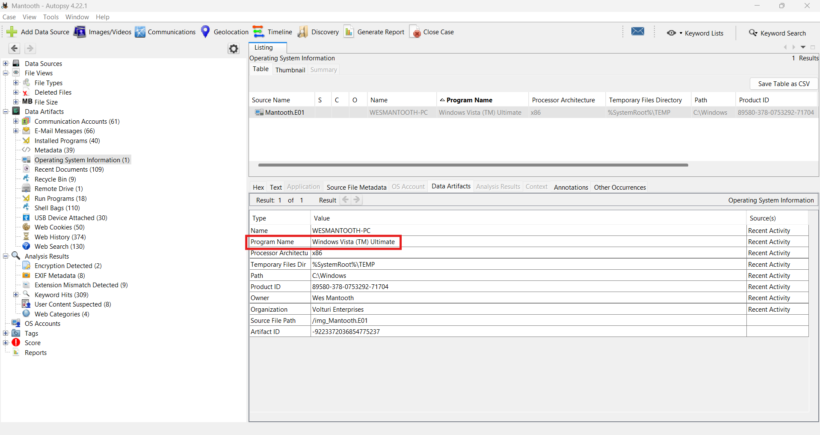

Figure shows the operating system the device is running on

**5. Time Zone: What time zone is the computer set to?**

The Time zone is set to America/New York (EST)

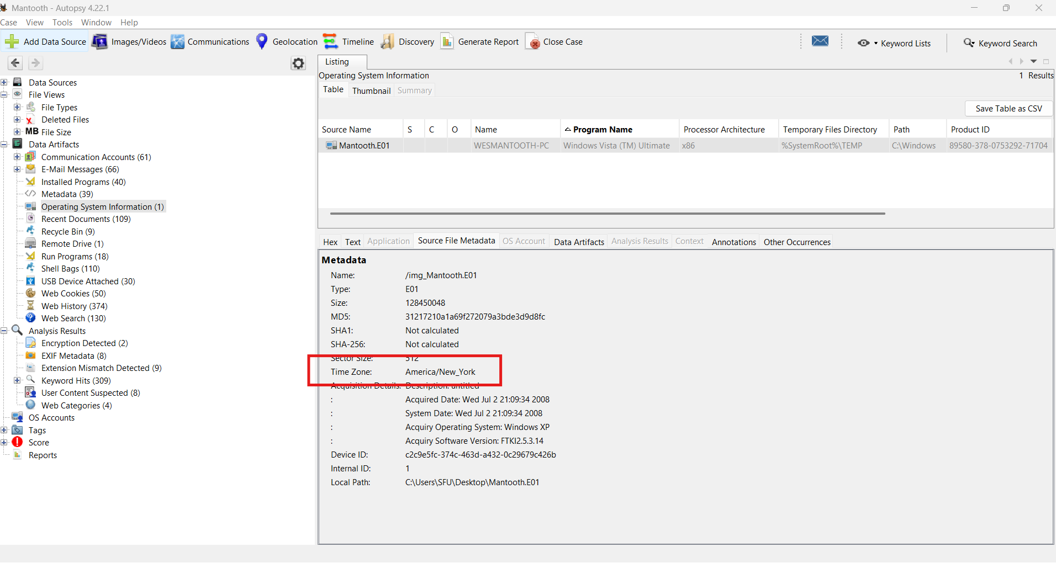

Figure shows the time zone the device is set to

**6. USB Device History: Find one USB storage device that was connected to the computer and provide the make/model/serial number.**

Make: Microsoft Corp.

Model: IntelliMouse Optical

Serial: 5&40df8c9&0&2

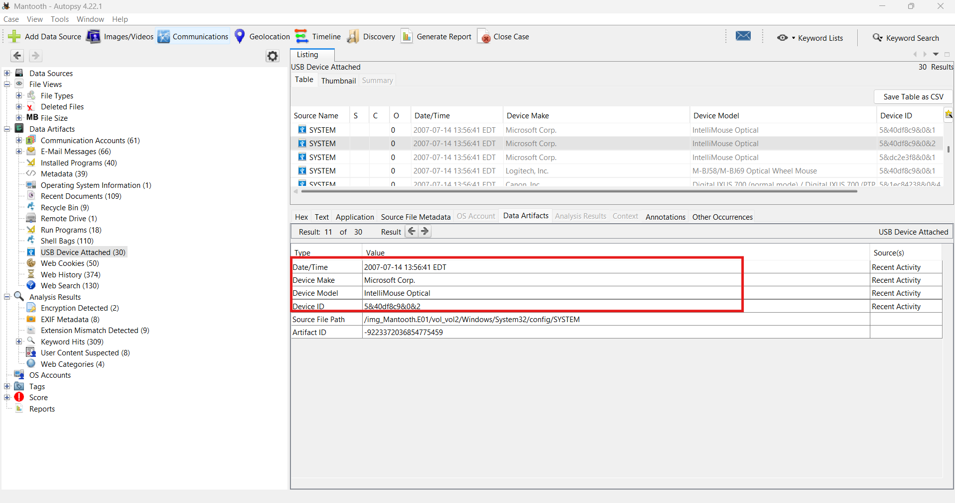

Figure shows a usb storage device that was connected to the computer

**7. Browser History: Identify at least three websites the user has visited.**

According to browser history the user Visited [Snopes.com](http://snopes.com), [Phys.org](http://phys.org), and [SCCJA.org](http://sccja.org). For SCCJA that didn’t exist but [SCCJA.gov](http://sccja.gov) (South Carolina Criminal Justice Academy) does exist. So I find it possible the user meant that site instead.

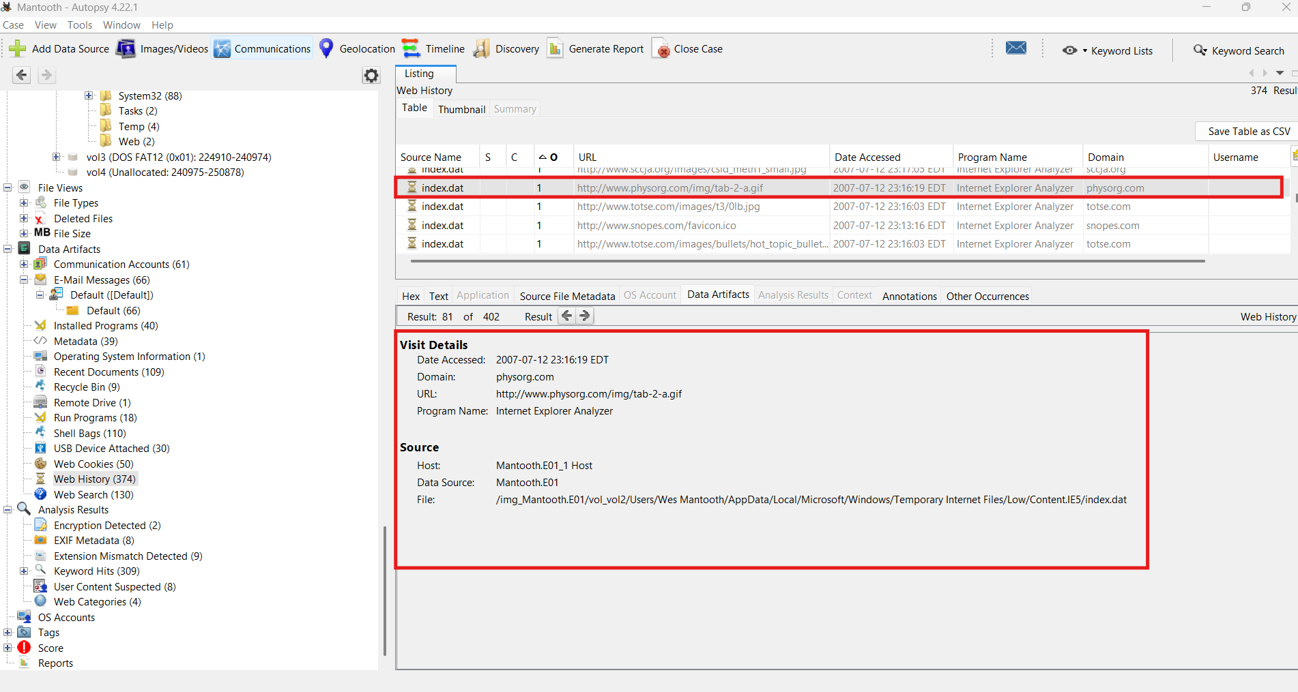

Figure shows the browser history of Phsy.org

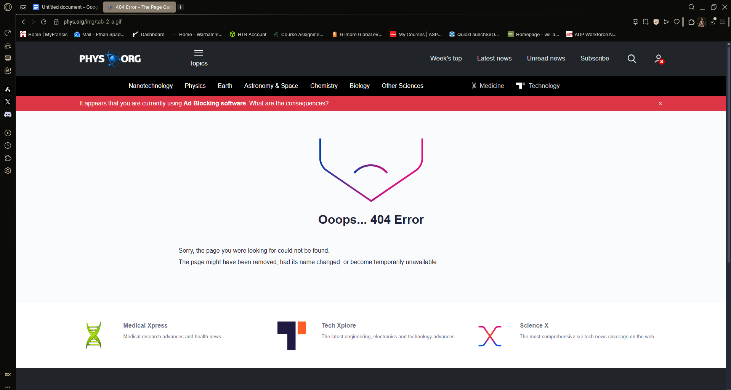

Figure shows the non-existent page on Phys.org the user visited

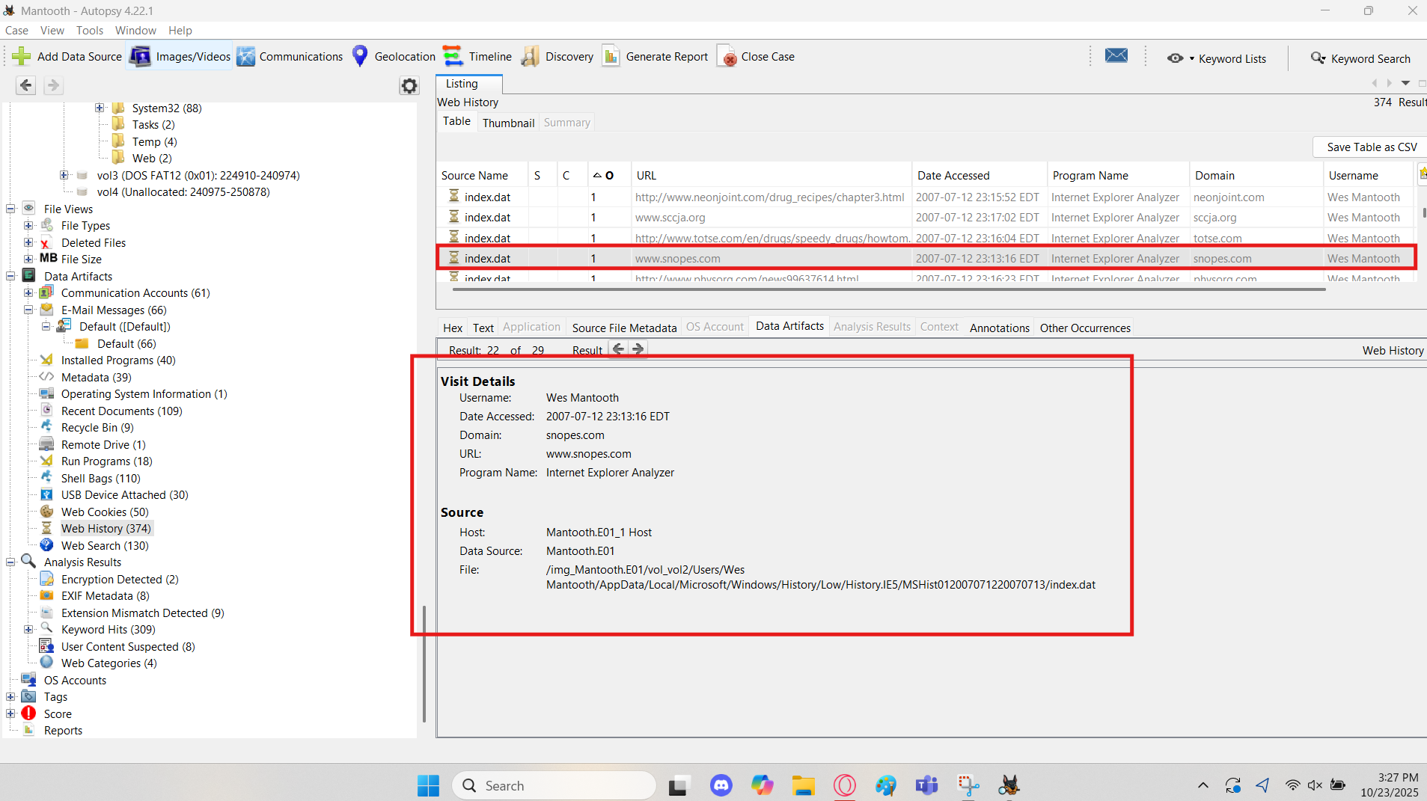

Figure shows the browser history of Snopes.com

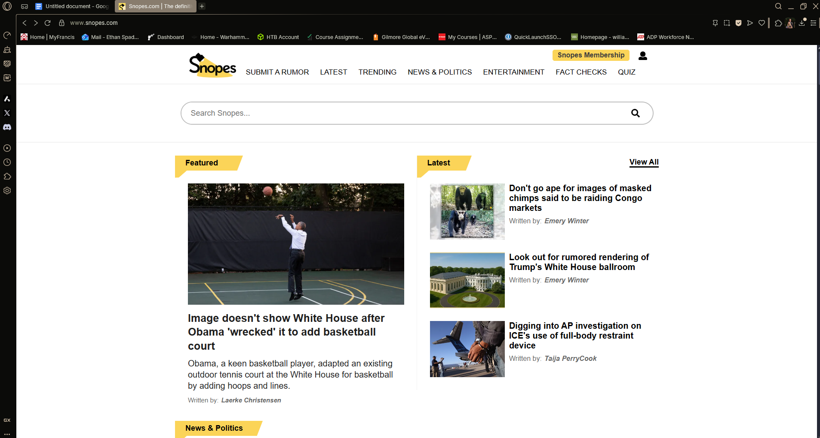

Figure shows the home page of Snopes.com

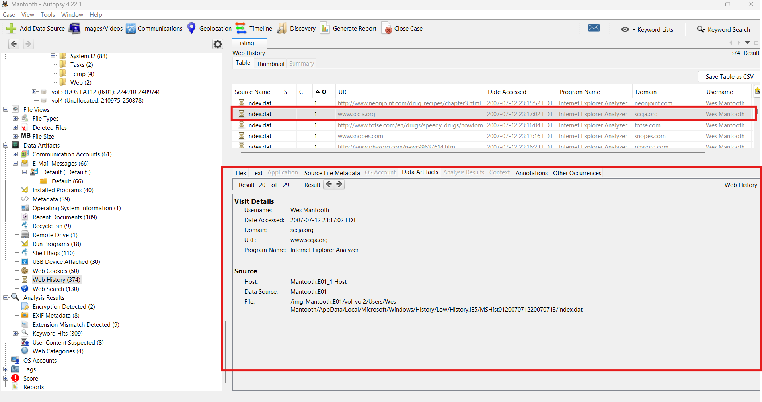

Figure shows the web history of SCCJA.org\



Figure shows the non-existent page of SCCJA.org that the user visited

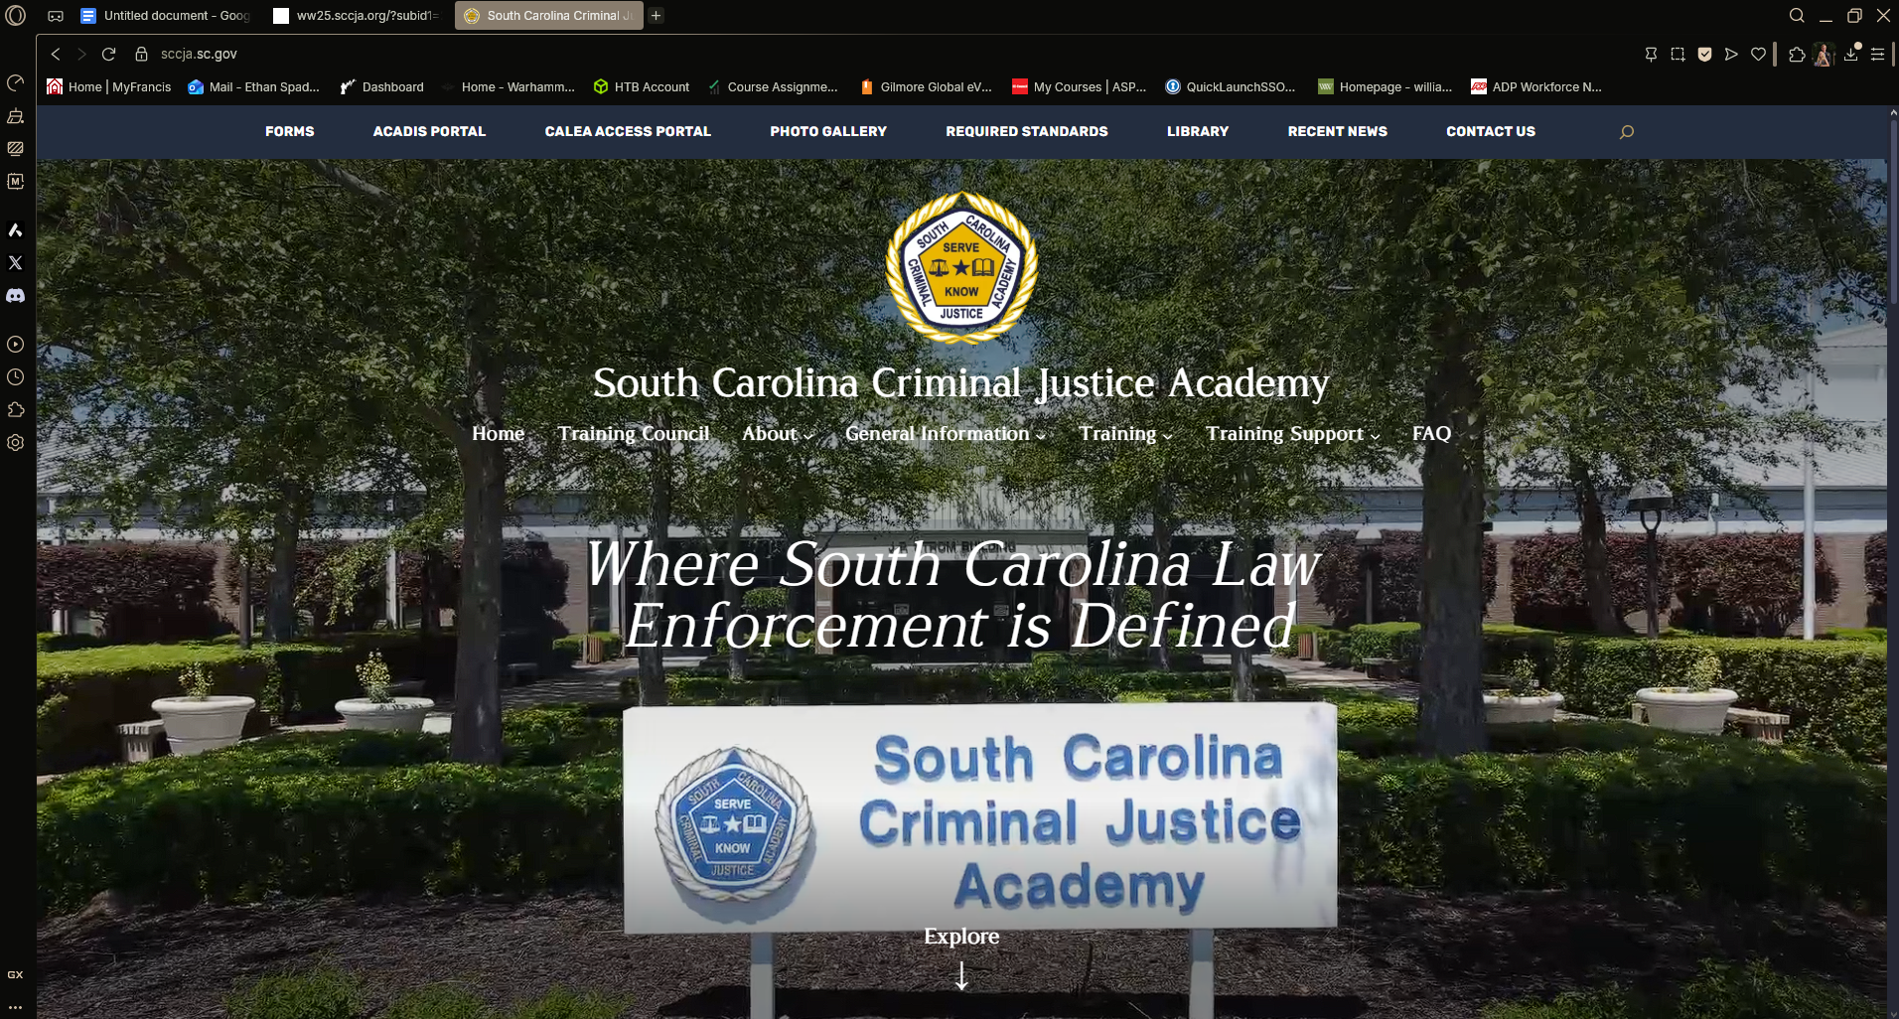

Figure Shows SCCJA.gov which is presumably the site the user meant to visit

**8. Browser History: Identify any suspicious search queries.**

The user was looking up not only how to make meth but also how to steal ATM cards

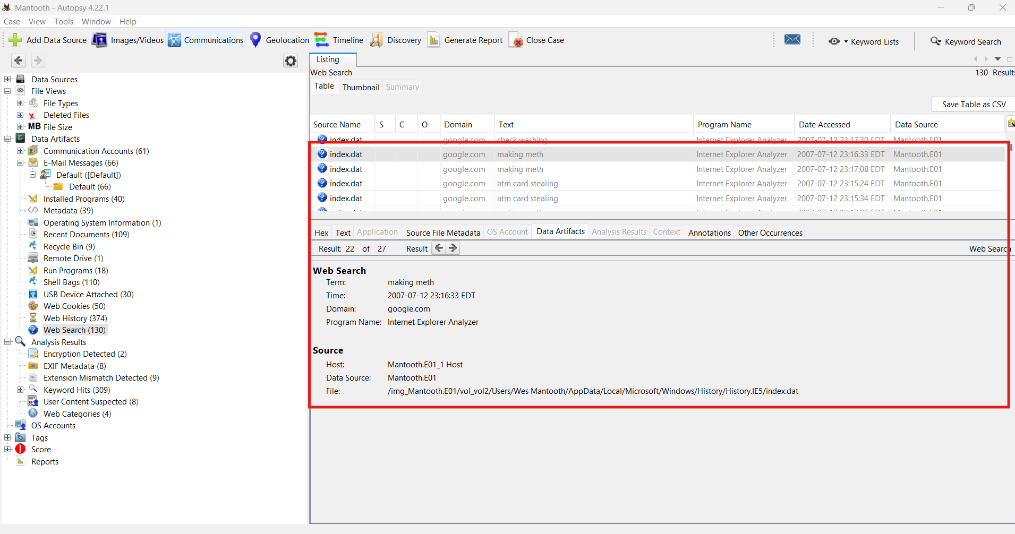

Figure shows several nefarious seraches found in the users browser history

**9. Email Attachments: Find at least one email attachment that the user sent.**

The user sent an email with a picture of his “Girlfriend” attached which is just a screenshot of Avril Lavigne from her Girlfriend music video.

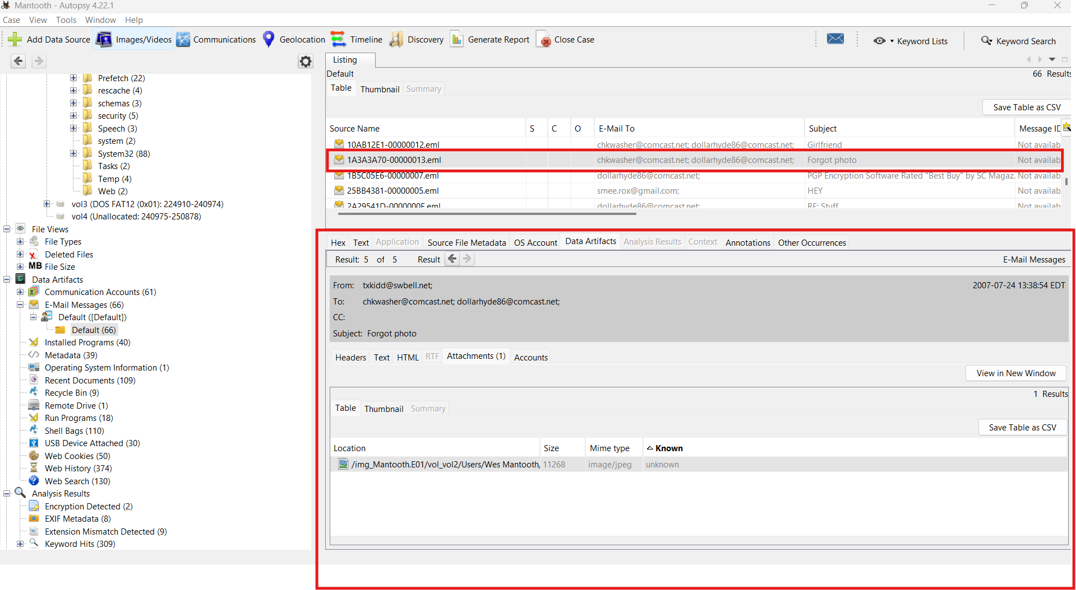

Figure shows the original attachment and email the user sent



Figure shows the hottest woman known to man

**10. Email Artifacts: Locate at least one email address used on the computer.**

The user had an email address they sent messages with under the name Dollarhyde86@comcast.net

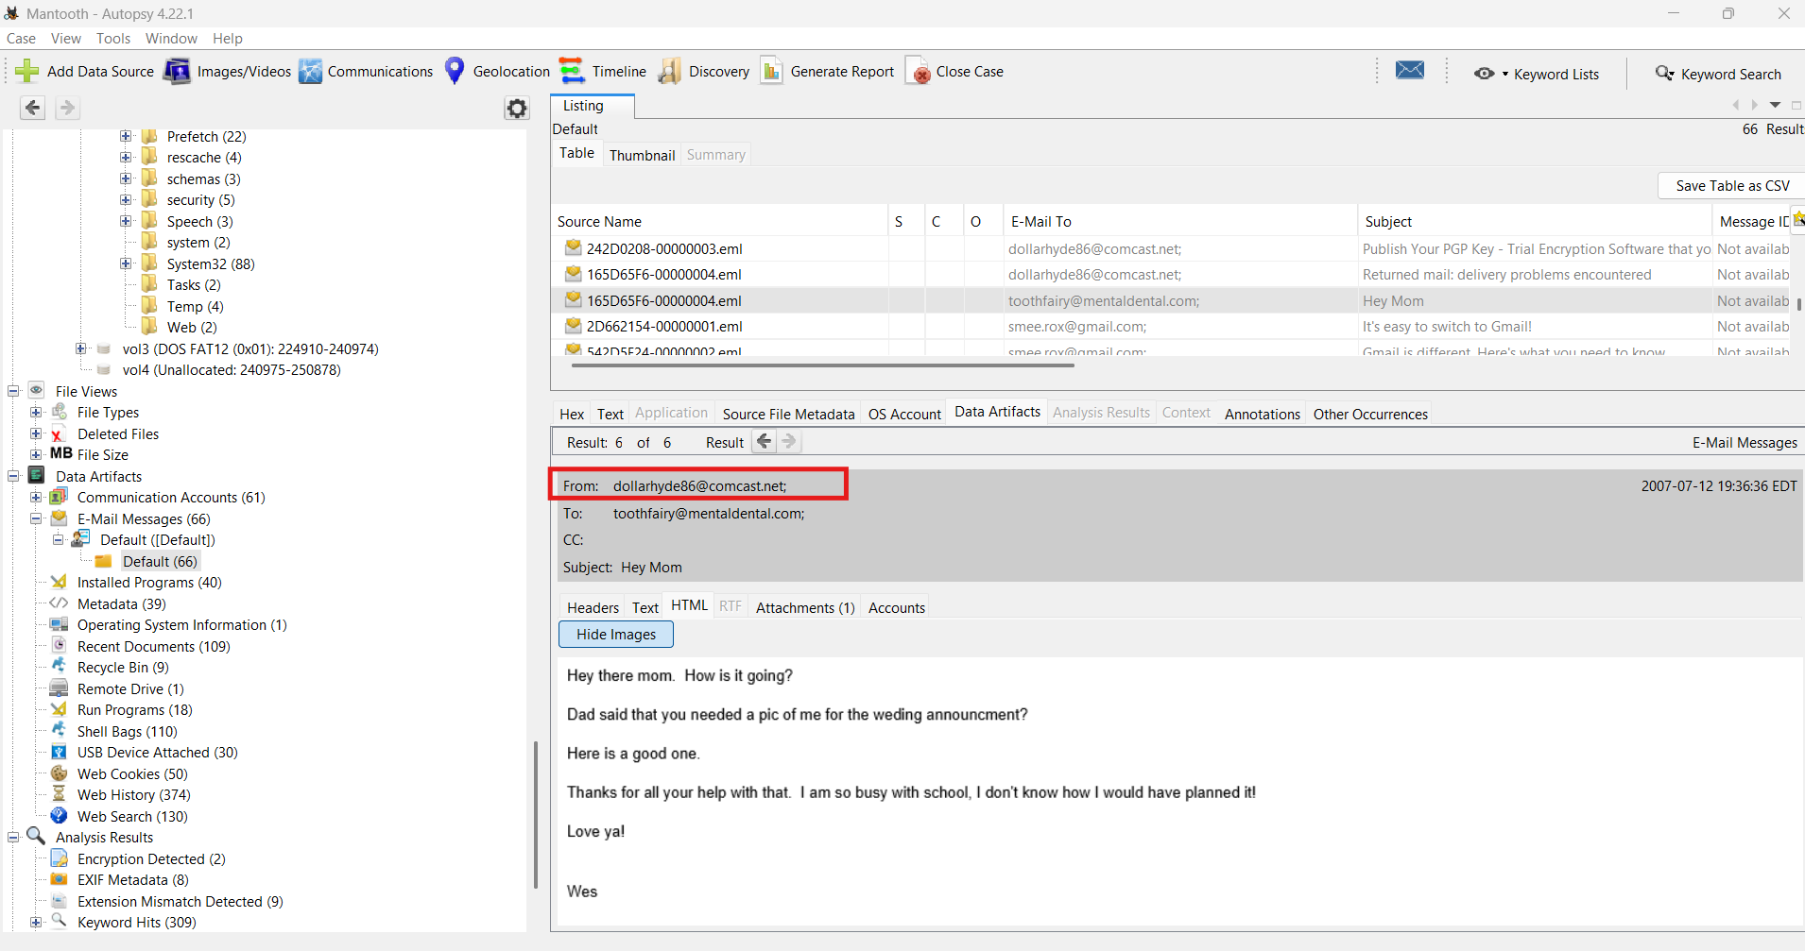

Figure shows an email address used by Wes Mantooth

**11. Pictures: Identify at least three images that could be meaningful.**

Three Images I found were of Wes himself that he sent to his mother via email, a hand putting a skimmer onto an ATM, which when combined with previous findings related to stealing ATM cards could be meaningful. And finally an image of a chemistry kit, which considering the users previous search of how to make meth, could be meaningful.



Figure shows a photo of Wes Mantooth himself

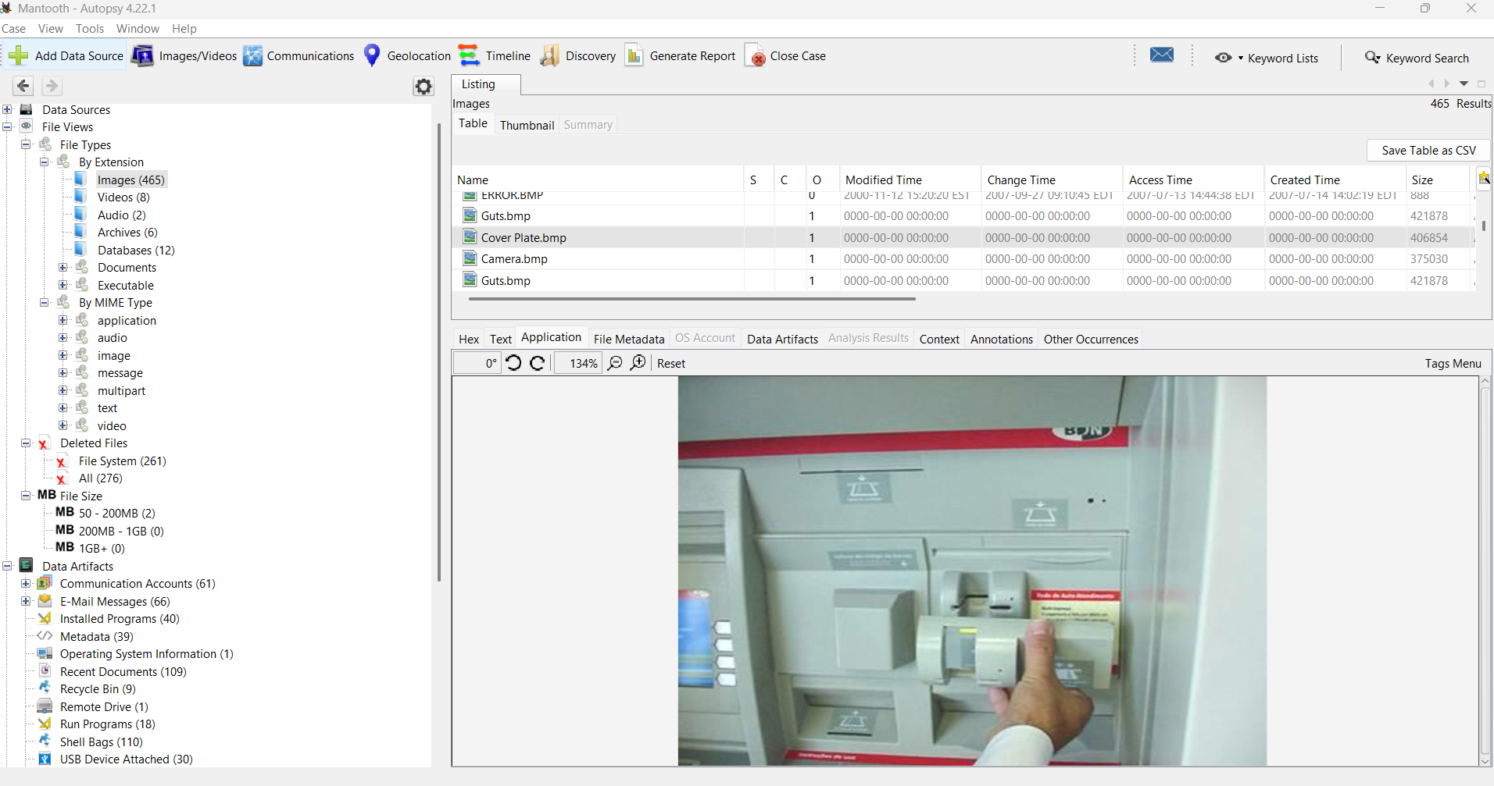

Figure shows an ATM skimmer being applied

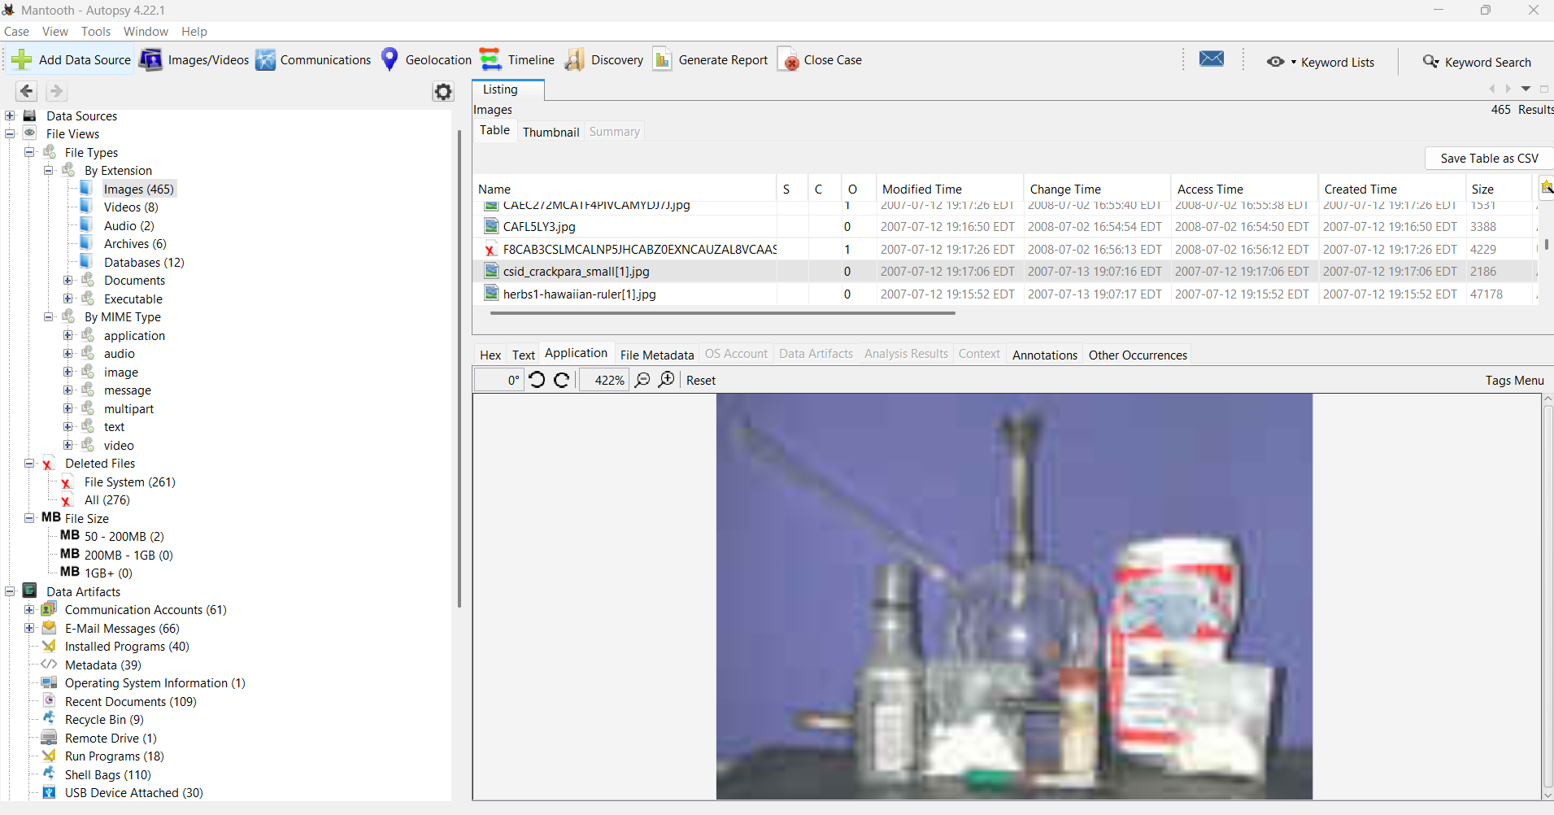

Figure shows a chemistry set

**12. Software: Identify at least three programs that are installed on the computer. Note any suspicious applications and why.**

The software found on the users device are Trillian, Mplayer2, and Scheduling agent.

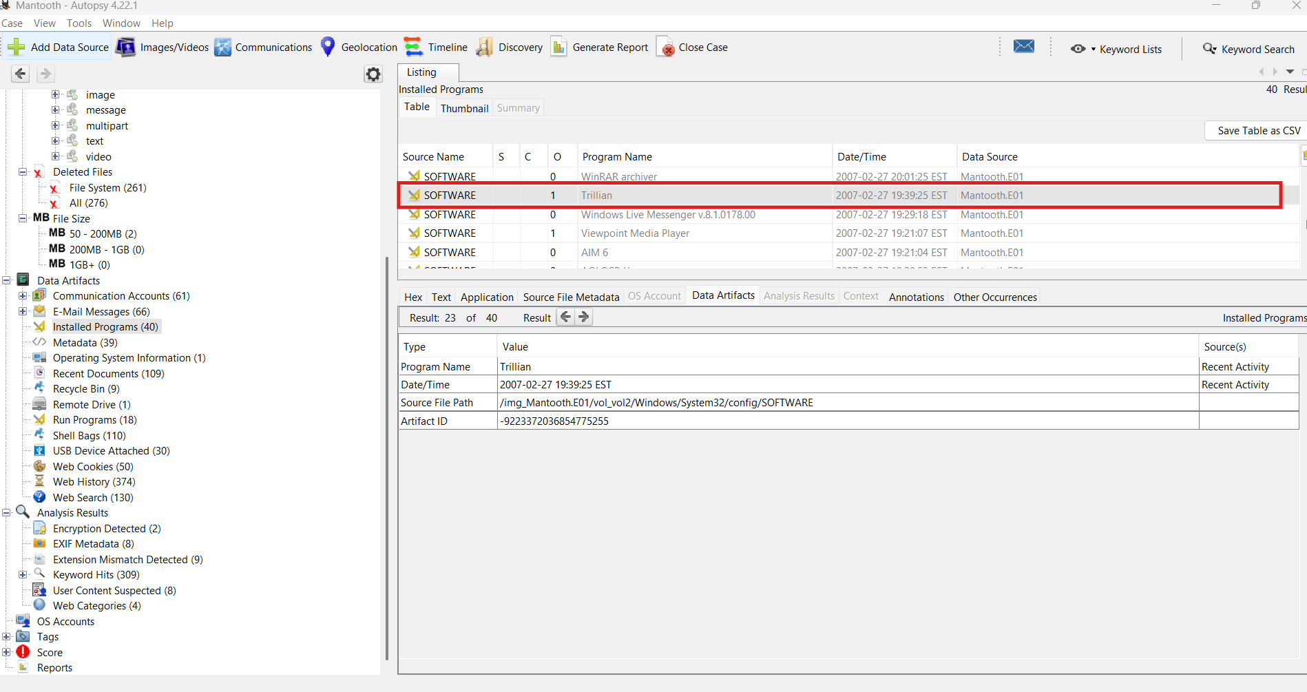

Figure shows Trillian software

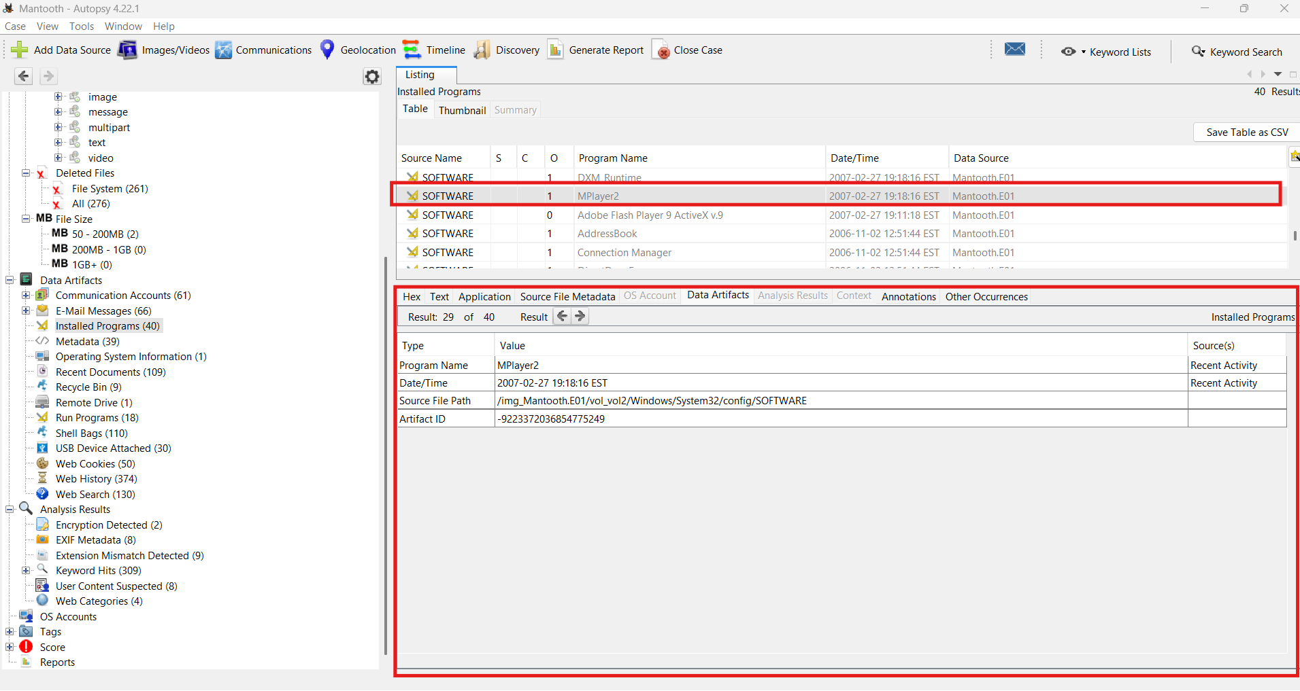

Figure shows MPlayer2

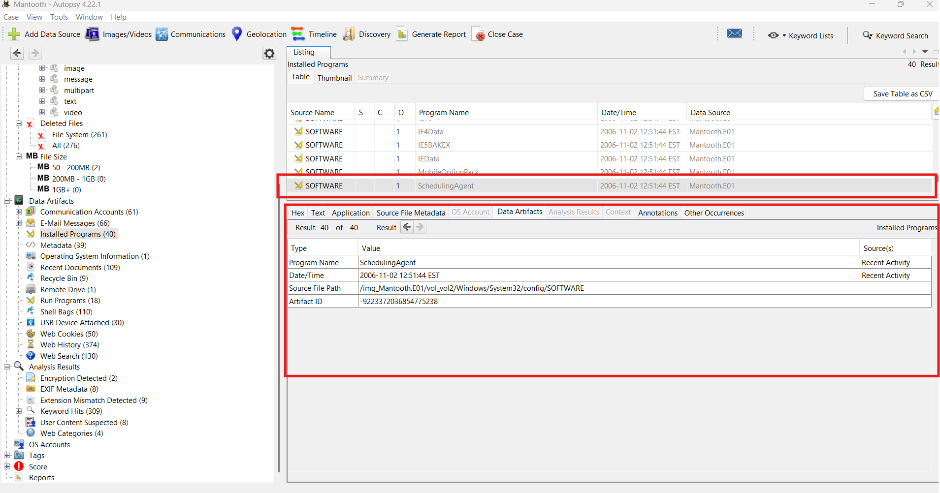

Figure shows schedule agent software

**13. Software: Identify any suspicious applications that the user has recently launched. When were the applications last run?**

The user had an application called Fontcore on their computer which upon looking into it applies malware and other such baddities to the users computer

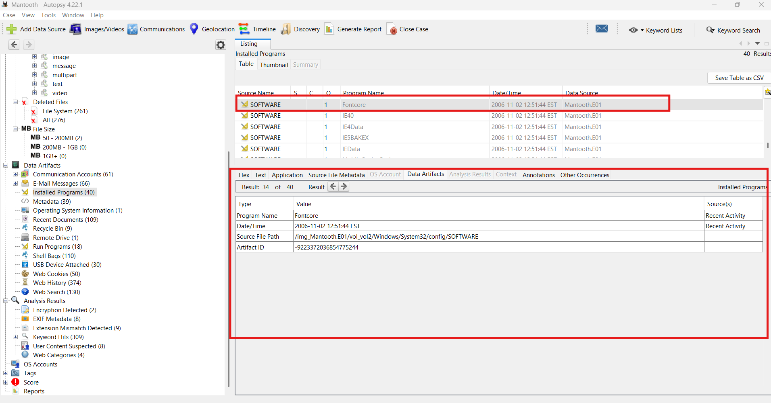

Figure shows fontcore software

**14. Deleted Files: Identify and recover a deleted file.**

The User had this photo of an angry Christmas Monkey in their recycling bin.



Figure Image of a stupid little rat monkey

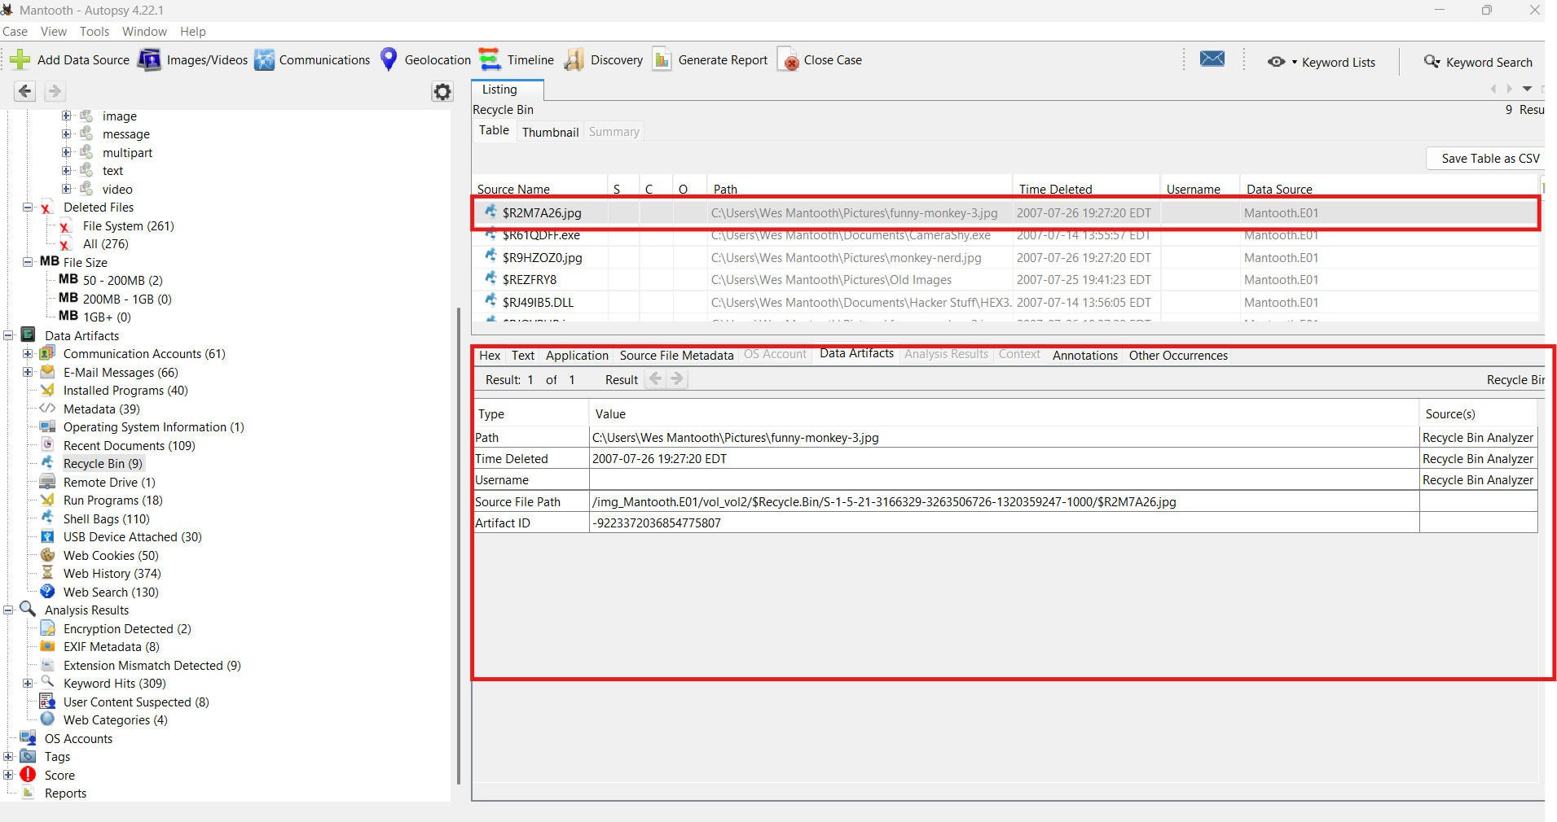

Figure shows the monkey image in the recycling bin, where that stupid little rat belongs

**15. Did you discover any other interesting evidence on the computer?**

Emails were found between Wes and someone named John Washer talking indirectly about making meth.

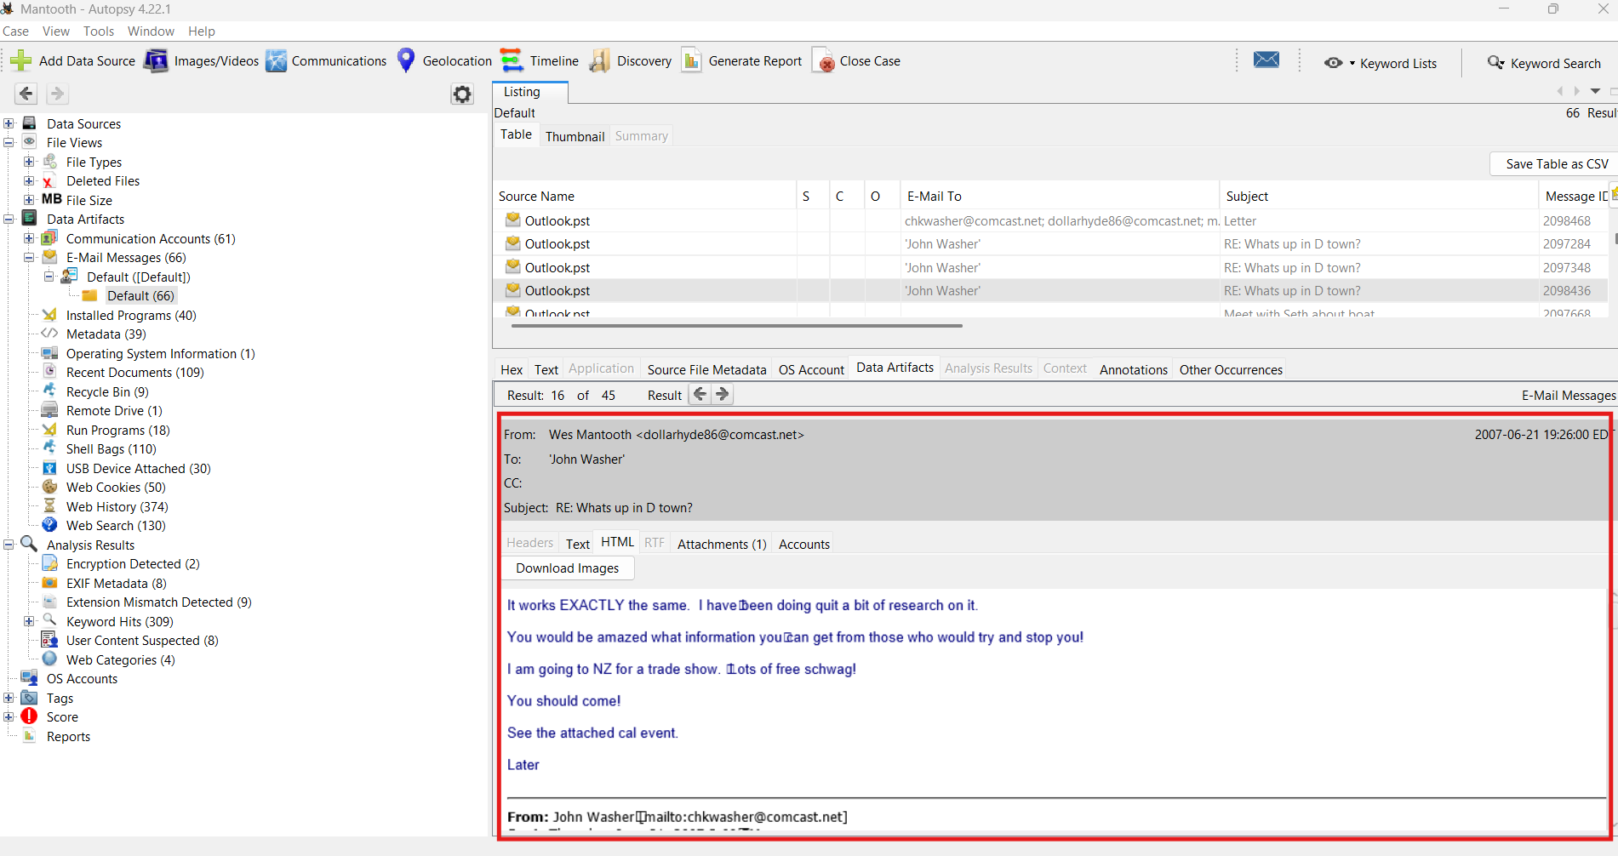

Figure shows user discussing his way of making meth

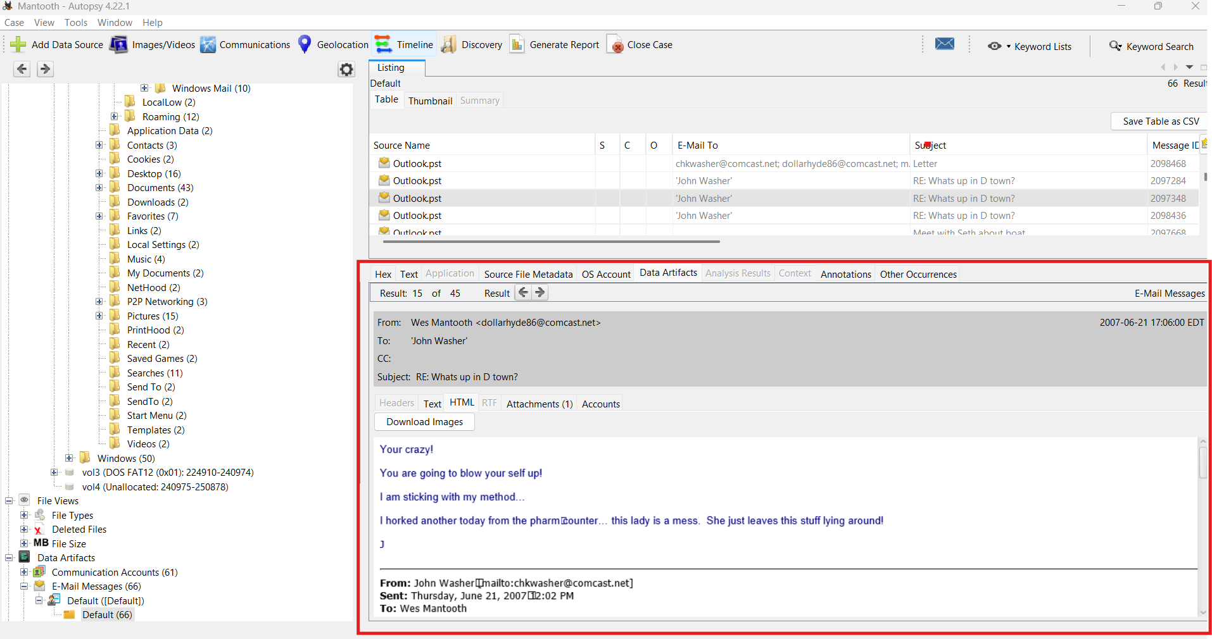

Figure shows the recipient not approving of Wes' meth making strategy

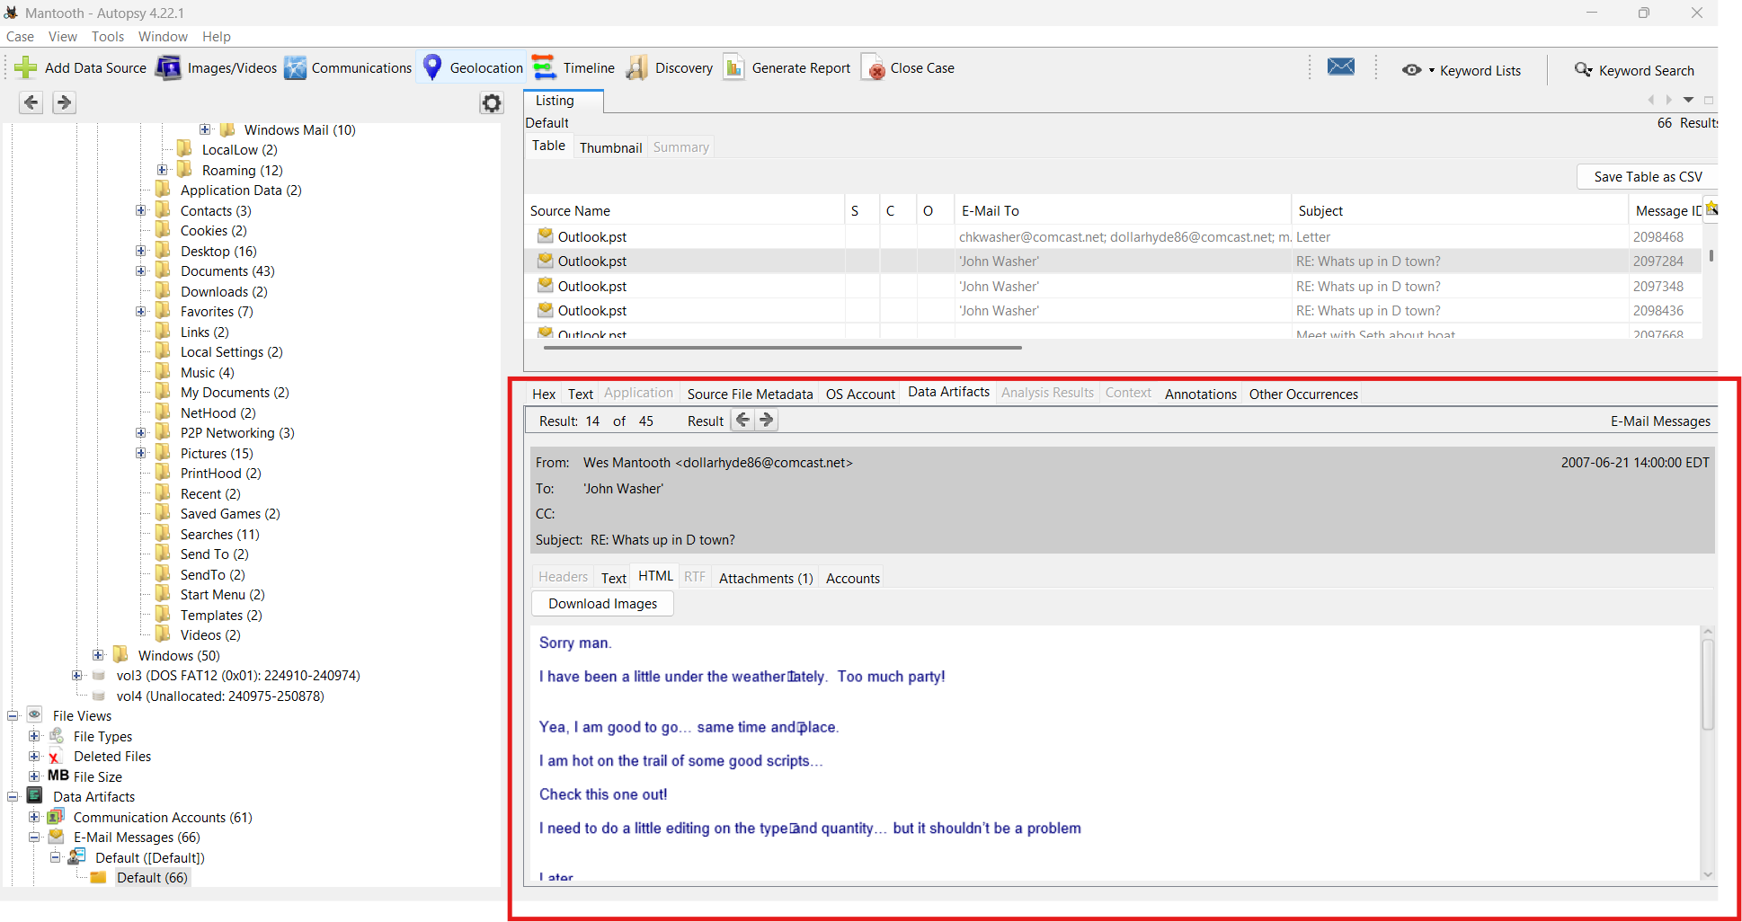

Figure shows Wes making plans

**5. Analysis Summary**

The artifacts collectively paint a consistent narrative of a user engaging in both personal communication and questionable digital behavior. The searches related to methamphetamine production and ATM skimming, combined with email exchanges and corroborating images, indicate potential intent to engage in illegal activity.

Additionally, the presence of Fontcore malware suggests the user may have interacted with or deployed harmful software. These findings, while not definitive proof of a crime, represent strong circumstantial evidence warranting further investigation.

**6. Conclusion**

The forensic investigation of the Mantooth.E01 image successfully identified the primary user, reconstructed their digital behavior, and uncovered multiple suspicious activities. Artifacts from system logs, browser history, and email correspondence corroborate one another to establish a cohesive narrative of potential criminal intent.

All evidence is verifiable through associated MD5-validated files and should be preserved in accordance with forensic best practices for potential legal review.